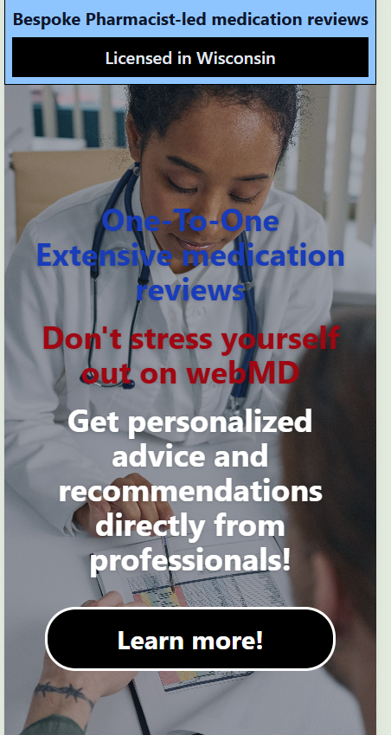
Licensed in Wisconsin should function as a button that opens the disclaimers and legal/licencing information. It will be in other locations too, but it's good to have this front and center

